**A PRELIMENERY REPORT ON**

**PLANT DISEASE DETECTION USING RESNET50**

SUBMITTED TO THE VISHWAKARMA INSTITUTE OF INFORMATION TECHNOLOGY, PUNE

IN THE PARTIAL FULFILLMENT OF THE REQUIREMENTS

FOR THE AWARD OF THE DEGREE

**BACHELOR OF TECHNOLOGY (COMPUTER ENGINEERING)**

##### SUBMITTED BY

|  |  |  |
| --- | --- | --- |
| Sr. No | Student Name | PRN |
| 1 | Abhaykumar Baral | 22110809 |
| 2 | Sai Kamble | 22220063 |
| 3 | Rushikesh Chaure | 22111006 |
| 4 | Harsh Sarpate | 22110367 |



## DEPARTMENT OF COMPUTER ENGINEERING

**BRACT’S**

**VISHWAKARMA INSTITUTE OF INFORMATION TECHNOLOGY**

SURVEY NO. 3/4, KONDHWA (BUDRUK), PUNE – 411048, MAHARASHTRA (INDIA).

|  |  |  |  |  |  |
| --- | --- | --- | --- | --- | --- |
| **Sr. No.** | | | | **Title of Chapter** | **Page No.** |
| **01** | | | | **Introduction** |  |
|  | 1.1 | | | Overview | 3 |
|  | 1.2 | | | Motivation | 3 |
|  | 1.3 | | | Problem Definition and Objectives | 3 |
|  | 1.4 | | | Project Scope & Limitations | 4 |
|  | 1.5 | | | Methodologies of Problem solving | 5 |
| **02** | | | | Literature Survey | 6 |
| **03** | | | | System Design |  |
|  | | 3.1 | | System Architecture | 8 |
| **04** | | | | Project Implementation |  |
|  | | | 4.1 | Overview of Project Modules | 11 |
|  | | | 4.2 | Tools and Technologies Used | 11 |
|  | | | 4.3 | Algorithm Details | 12 |
| **05** | | | | Results |  |
|  | | | 5.1 | Outcomes | 13 |
|  | | | 5.2 | Screen Shots | 14 |
|  | | | 5.3 | Confusion Matrix, Precision , Recall ,Accuracy,Specificity ,Sensitivity All Graph | 16 |
| **06** | | | | Conclusions |  |
|  | | 9.1 | | Conclusions | 19 |
|  | | 9.2 | | Future Work | 19 |
|  | | 9.3 | | Applications | 20 |

**1 INTRODUCTION**

* 1. **OVERVIEW**

The Plant Disease Detection system using ResNet is a software application designed to assist farmers in identifying diseases in plant leaves. By analyzing images, the system can classify them as healthy or diseased, aiding in timely intervention and treatment. It leverages ResNet, a deep learning model trained on plant images, for accurate classification. The system's scope includes features like image uploading, preprocessing, disease classification, and result display. It operates on standard hardware and common operating systems, with dependencies like Python and TensorFlow. Assumptions include access to labeled image data and user understanding of basic computer skills. Overall, the system aims to improve disease diagnosis, increase crop yield, and reduce manual effort in agriculture.

* 1. **MOTIVATION**

The motivation behind developing the Plant Disease Detection system using ResNet stems from the critical need to address plant diseases, which can significantly impact crop yield and food security. Traditional methods of disease detection often rely on manual inspection, which is time-consuming and may not always be accurate. By leveraging the power of deep learning and computer vision, the system offers a more efficient and reliable solution for detecting diseases in plant leaves. This can help farmers make informed decisions about crop management, leading to higher crop yields and reduced losses. Additionally, the system has the potential to promote sustainable agriculture practices by enabling targeted disease management and reducing the need for excessive pesticide use. Overall, the motivation is to provide a valuable tool that can positively impact agricultural practices and contribute to global food security.

* 1. **PROBLEM DEFINITION AND OBJECTIVES**

Problem Definition

The Plant Disease Detection system using ResNet addresses the challenge of accurately and efficiently identifying diseases in plant leaves. Traditional methods of disease detection rely on manual inspection, which can be time-consuming and prone to errors. By leveraging deep learning and computer vision techniques, the system aims to provide a more reliable and automated solution for detecting diseases in plants.

Objectives

Accurate Disease Detection: Develop a system that can accurately classify images of plant leaves as healthy or diseased, using a pre-trained ResNet model.

Efficient Diagnosis: Provide a tool that can quickly analyze images and provide disease diagnosis, aiding farmers in timely intervention and treatment.

Scalability and Reliability: Design the system to be scalable, allowing for the analysis of large volumes of images, and reliable, ensuring consistent performance.

Promote Sustainable Agriculture: By enabling early detection and targeted disease management, the system aims to reduce the use of pesticides and promote sustainable agricultural practices.

* 1. **PROJECT SCOPE AND LIMITATIONS**

Project Scope

The project aims to develop a software application, the Plant Disease Detection system using ResNet, to assist farmers and agricultural professionals in identifying diseases in plant leaves. The system will leverage deep learning and computer vision techniques, specifically the ResNet model, to analyze images of plant leaves and classify them as healthy or diseased. The scope also includes testing the system for accuracy, performance, and usability to ensure it meets the specified requirements.

Limitations

1. Dependency on Data Quality: The accuracy of the system depends on the quality of the labeled image data used for training the ResNet model. Poor-quality or insufficient data may lead to inaccurate classification results.

2. Hardware and Internet Connectivity: The system's performance may be limited by the hardware it runs on, and certain features may require internet connectivity, which could be a limitation in areas with poor connectivity.

3. Model Generalization: The ResNet model, while effective, may not generalize well to all types of plant diseases or conditions. It may require further fine-tuning or training on specific datasets to improve performance.

* 1. **METHODOLOGIES OF PROBLEM SOLVING**

1. Define the Problem: Clearly define the problem of identifying diseases in plant leaves and understand its significance in agriculture.

2. Research and Analysis: Conduct research on plant diseases, ResNet model, and image classification techniques. Analyze existing datasets and research papers related to plant disease detection.

3. Identify Possible Solutions: Explore the use of ResNet for image classification in plant disease detection. Consider other deep learning models and image processing techniques.

4. Evaluate Solutions: Evaluate the effectiveness of using ResNet for plant disease detection based on factors such as accuracy, speed, and resource requirements. Compare ResNet with other potential solutions.

5. Develop a Plan: Create a plan for implementing ResNet for plant disease detection, including data collection, model training, and result evaluation.

6. Implement the Solution: Implement the plan by collecting labeled images of plant leaves, training the ResNet model, and testing its performance on a separate dataset.

7. Monitor and Evaluate: Monitor the performance of the ResNet model on new data and evaluate its accuracy in detecting plant diseases.

8. Iterate and Improve: Iterate on the ResNet model by fine-tuning its parameters and architecture to improve its performance in plant disease detection.

9. Document and Communicate: Document the process of using ResNet for plant disease detection, including the methodology, results, and lessons learned. Communicate the findings to stakeholders and the research community.

**2. LITERATURE SURVEY**

1. Plant Disease Detection and Classification by Deep Learning by LILI LI, SHUJUAN ZHANG, BIN WANG.

In this paper, they have introduced the basic knowledge of deep learning and presented a comprehensive review of recent research work done in plant leaf disease recognition using deep learning. Provided sufficient data is available for training, deep learning techniques are capable of recognizing plant leaf diseases with high accuracy. The importance of collecting large datasets with high variability, data augmentation, transfer learning, and visualization of CNN activation maps in improving classification accuracy, and the importance of small sample plant leaf disease detection and the importance of hyper-spectral imaging for early detection of plant disease have been discussed. At the same time, there are also some inadequacies.

1. Tomato Leaf Diseases Detection Using Deep Learning Technique by Muhammad E.H. Chowdhury, Tawsifur Rahman, Amith Khandakar, Nabil Ibtehaz, Aftab Ullah Khan, Muhammad Salman Khan, Nasser Al-Emadi, Mamun Bin Ibne Reaz, Mohammad Tariqul Islamand Sawal Hamid Md. Ali.

There are various pre-trained models, such as ResNet, MobileNet, DenseNet201 and Inceptions V3. But they found That DenseNet201 gives the high accuracy as compared to other models . So this trained model can be used to find thedisease at early stage so preventive actions can be taken faster. The proposed model can be combined with feedback system so appropriate controls techniques and preventive action can be taken, resulting in improving the crop production.

1. Plant Disease Identification Based on Deep Learning Algorithm in Smart Farming by Yan Guo, Jin Zhang, Chengxin Yin, Xiaonan Hu, Yu Zou, Zhipeng Xue, Wei Wang.

In the complex environment achieving the high accuracy is difficult. In order to solve this issue author proposed RPN algorithm, CV algorithm, and TL algorithm, so we can solve the issue of identification in complex environment. As compare to traditional models this model is more robust and gives high accuracy. Thus, the model can help farmersto increase the production by preventing and curing the plant disease quickly.

1. Leaf Disease Detection using Deep Learning Algorithm by Kishori Patil, Santosh Chobe.

Here, how the disease analysis is done for the leaf diseases detection is addressed, the analysis of the different diseases that are present on the leaves can be effectively detected in the early stage before it can damage the whole plant. Here the technique presented can able to detect the disease more accurately, we can say that, we can archive good productivity by preventing the different diseases which are present on the leaves of plant using weather dataset and image processing.

**3. SYSTEM DESIGN**

3.1 SYSTEM ARCHITECTURE

+-----------------+

| Input | (Plant Leaf Image)

+-----------------+

|

V

+-----------------+

| Preprocessing |

+-----------------+

|

V

+-----------------+

| ResNet-50 (Feature Extraction) |

| (4 Stages with Convolutional |

| Blocks and Residual Connections) |

+-----------------+

|

V

+-----------------+

| Global Average Pooling |

+-----------------+

|

V

+-----------------+

| Fully Connected Layers |

+-----------------+

|

V

+-----------------+

| Output | (Disease Probability Distribution)

+-----------------+

1. Preprocessing:

Input: This block takes an image of a plant leaf (or other relevant part) as input.

Preprocessing Steps:

Resize: The image is resized to a standard size, commonly 224x224 pixels for ResNet-50.

Normalization: Pixel values are normalized, often to a range of 0-1 or -1 to 1.

(Optional) Data Augmentation: Random transformations (flips, rotations) can be applied to increase the variety of training data.

2. ResNet-50 Feature Extraction:

Stages: ResNet-50 is made up of four main stages, each containing several convolutional blocks. These stages progressively extract higher-level features from the image.

Convolutional Blocks: Each block follows a similar pattern:

1x1 Convolution: Reduces the dimensionality of the data (often used for bottlenecking in ResNet-50).

3x3 Convolution: Extracts spatial features from the image.

Batch Normalization: Improves the stability of the training process.

Activation Function (ReLU): Adds non-linearity to the data, allowing the network to learn more complex patterns.

1x1 Convolution: Increases the dimensionality back to the desired level.

3x3 Convolution: Extracts more features from the image.

Batch Normalization: Improves training stability.

Activation Function (ReLU): Adds non-linearity.

Residual Connections: A key feature of ResNet. These connections directly add the input of a block to its output, allowing the network to learn from deeper layers and alleviate the vanishing gradient problem.

Not all blocks in ResNet-50 have residual connections. Some connections use strided convolutions (downsampling) to reduce the image size as we move through stages.

3. Classification:

Global Average Pooling: This layer averages the values from each feature map in the final convolutional layer of ResNet-50. This results in a fixed-size vector representing the overall features of the image.

Fully Connected Layers: One or two fully connected layers are typically added on top of the flattened feature vector.

These layers learn the relationship between the extracted features and the disease classes.

The number of neurons in the final layer is equal to the number of disease classes you want to detect (e.g., healthy, soybean rust, etc.).

Output Layer:

This layer uses a softmax activation function to produce a probability distribution for each disease class. The softmax function ensures the probabilities sum to 1, indicating the likelihood of each class being present in the image.

The class with the highest probability is predicted as the disease affecting the plant in the image.

1. **PROJECT IMPLEMENTATION**
   1. **Overview of Project Modules**

The project comprises several key modules:

(1) Data Collection and Preprocessing, involving gathering and enhancing images of healthy and diseased plants.

(2) Model Training, where a ResNet model is trained on the preprocessed images to classify diseases.

(3) Model Evaluation, to assess the trained model's performance.

(4) Deployment, to integrate the model into a real-time detection system.

(5) User Interface, providing an intuitive interface for users to interact with the system.

(6) Database, optionally storing information on plant diseases for system enhancement.

(7) Feedback Loop, enabling the system to learn from new data and user inputs for continuous improvement.

(8) Integration, ensuring seamless communication between modules.

(9) Testing and Validation, to ensure the system meets requirements.

(10) Maintenance and Updates, for ongoing system maintenance and improvement.

* 1. **TOOLS AND TECHNOLOGIES USED**

The tools and technologies used in a plant disease detection project using ResNet include:

1. Python: Programming language used for developing the project due to its popularity in machine learning and deep learning.

2. TensorFlow or PyTorch: Deep learning frameworks for building, training, and deploying neural network models like ResNet.

3. OpenCV: Library for image processing and computer vision tasks, useful for preprocessing plant images.

4. Google Colab : For prototyping, experimenting, and training the ResNet model on cloud resources.

5. Image Dataset: A dataset of plant images containing both healthy and diseased samples for training and validation.

These tools and technologies provide a robust framework for developing and deploying a plant disease detection system using ResNet, enabling efficient and accurate detection of plant diseases.

* 1. **ALGORITHM DETAILS**

The algorithm for plant disease detection using ResNet-50 can be broken down into several stages:

* Preprocess the input image (resize, normalize, optionally augment).
* Perform a forward pass through the ResNet-50 model to extract features.
* Apply global average pooling to create a feature vector.
* Pass the feature vector through fully connected layers.
* Use the softmax function in the output layer to get disease class probabilities.
* Predict the disease with the highest probability.

1. **RESULTS**
   1. **OUTCOMES**

The outcomes of a plant disease detection project using ResNet can be significant and beneficial, including:

1. Early Disease Detection: The system can detect diseases in plants at an early stage, allowing for timely intervention and treatment, which can help prevent the spread of diseases and minimize crop damage.

2. Improved Crop Yield: By detecting and managing diseases early, farmers can improve the overall health of their crops, leading to higher yields and better quality produce.

3. Reduced Costs: Early disease detection can reduce the need for costly treatments and pesticides, saving farmers money and reducing the environmental impact of farming practices.

4. Data-Driven Insights: The system can provide valuable insights into disease patterns and trends, helping farmers make informed decisions about crop management and disease prevention strategies.

5.Accessibility: By deploying the system online or through mobile applications, farmers in remote or underserved areas can access the benefits of disease detection technology, improving overall agricultural practices and sustainability.

Overall, the outcomes of a plant disease detection project using ResNet can lead to improved crop health, increased yields, and more sustainable farming practices, benefiting both farmers and the environment.

* 1. **SCREENSHOTS**

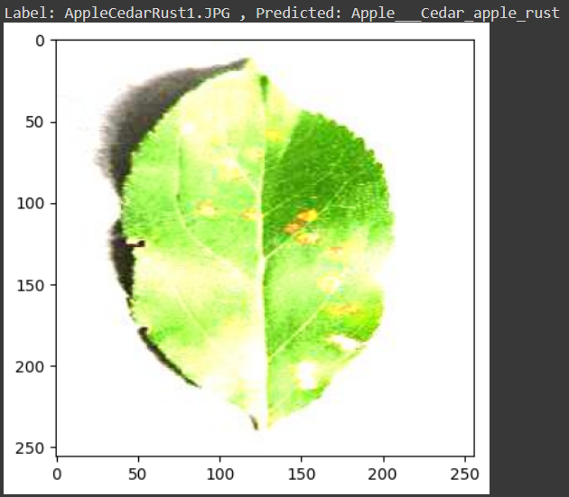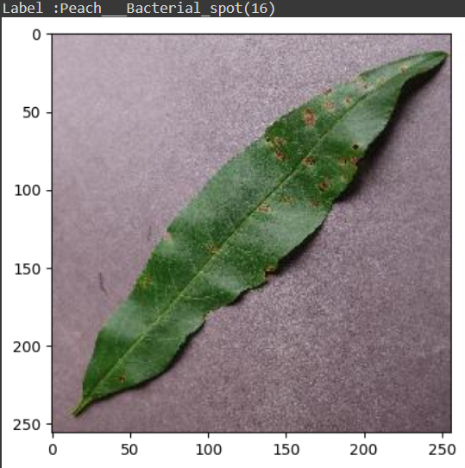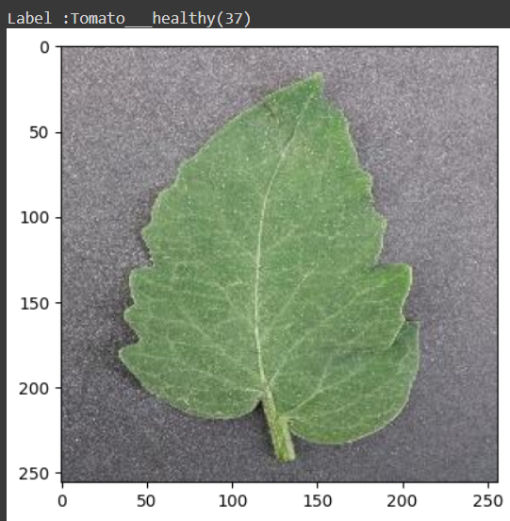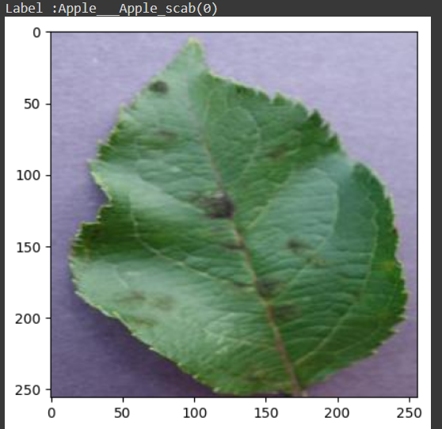

**5.3 CONFUSION MATRIX, PRECISION , RECALL ,ACCURACY,SPECIFICITY ,SENSITIVITY ALL GRAPH**

1 Confusion Matrix

A confusion matrix is a table that is often used to describe the performance of a classification model on a set of test data for which the true values are known. It allows the visualization of the performance of an algorithm

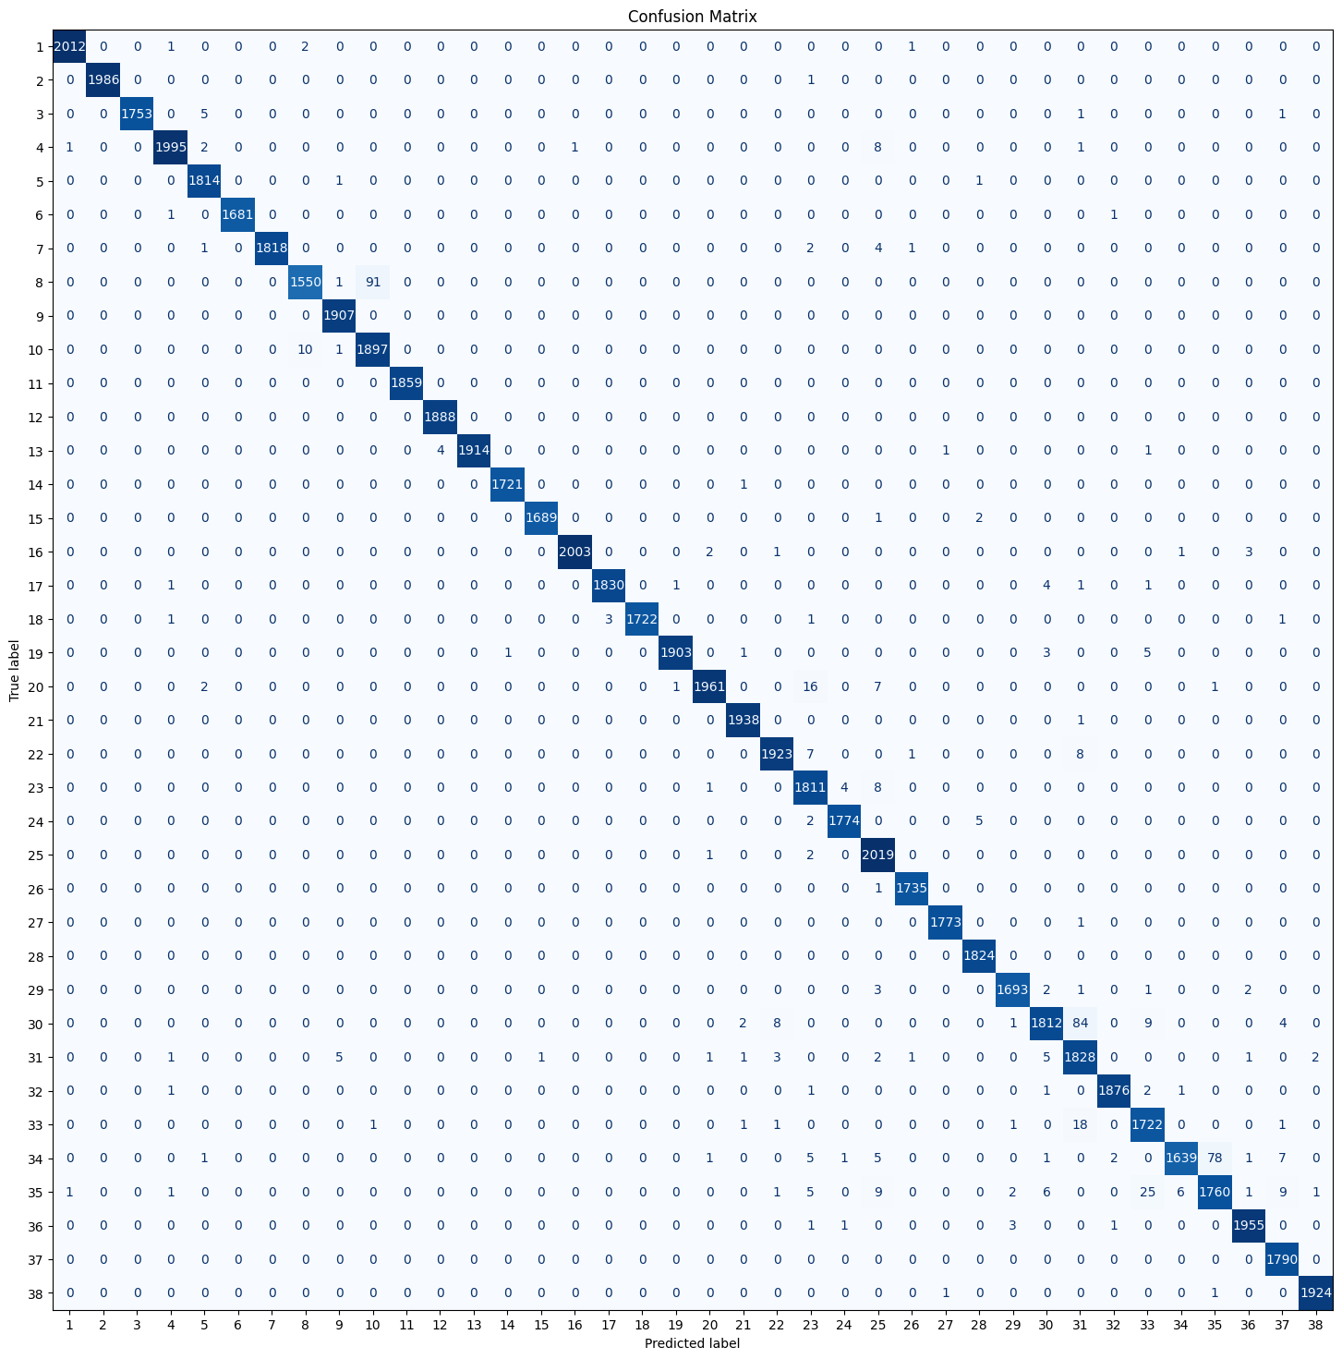

2 Precision, Recall, F1 score

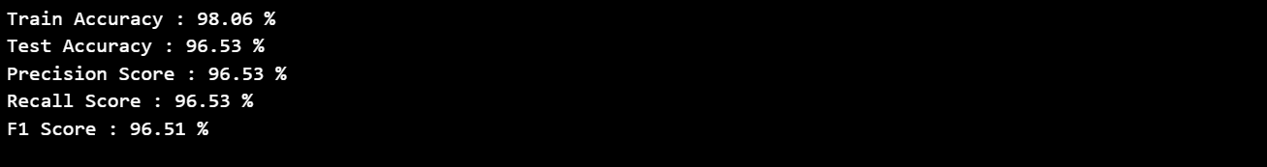

1. Accuracy

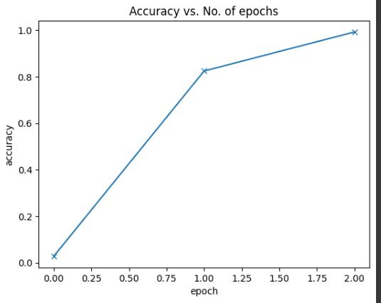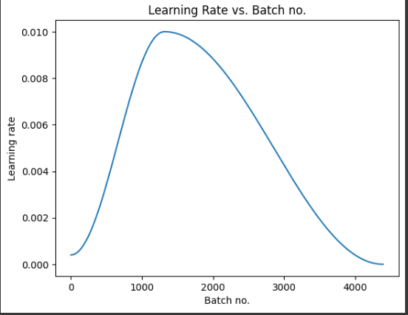

**6 CONCLUSIONS**

**6.1 Conclusions**

In conclusion, developing a plant disease detection system using ResNet can offer significant benefits for agriculture and crop management. By leveraging deep learning techniques, such a system can accurately and efficiently identify diseased plants, enabling farmers to take timely action to mitigate crop damage and improve yields. The use of ResNet, with its deep architecture and ability to learn intricate patterns from images, enhances the system's capability to classify plant diseases with high accuracy. Additionally, the system's potential for real-time disease detection can help farmers make informed decisions about disease management strategies, leading to more sustainable and productive agricultural practices. Overall, a plant disease detection system based on ResNet represents a valuable tool for modern agriculture, offering a promising approach to address the challenges posed by plant diseases and contribute to food security.

**6.2 Applications**

The application of a plant disease detection system using ResNet is highly versatile and impactful across various agricultural domains. For farmers, the system offers a proactive approach to crop management by enabling early disease detection, thus minimizing crop losses and optimizing the use of resources like pesticides. Agricultural extension services can leverage this technology to provide targeted advice and recommendations, improving overall farm productivity. Researchers benefit from the system's ability to analyze disease patterns and trends, aiding in the development of disease-resistant crop varieties and sustainable farming practices. Government agencies can use the system for effective disease monitoring and surveillance at regional or national levels, facilitating timely intervention and control measures. Agri-tech companies can integrate the system into their offerings, providing farmers with advanced tools for disease management. Education and training programs can incorporate the system to enhance learning about plant diseases. Moreover, by reducing the reliance on pesticides and promoting sustainable practices, the system contributes to minimizing the environmental impact of agriculture. Overall, the application of a plant disease detection system based on ResNet holds immense potential for transforming agriculture, ensuring food security, and promoting environmental sustainability.

**6.3 Future Scope**

Looking ahead, the future of plant disease detection using ResNet holds immense potential for revolutionizing agricultural practices worldwide. Continued research and development efforts are likely to lead to significant advancements in the accuracy and efficiency of disease detection models. Integration with IoT devices and advancements in hardware and software technologies are expected to enable real-time monitoring of crops, allowing for early detection and proactive management of plant diseases. The integration of big data analytics and AI techniques will further enhance the ability to analyze large-scale agricultural data, leading to more effective disease management strategies. Mobile applications leveraging ResNet models will empower farmers to quickly assess crop health in the field, enabling timely interventions. Collaboration between researchers and agricultural stakeholders globally will drive the development of standardized datasets and models, fostering the widespread adoption of ResNet-based disease detection systems. Ultimately, these advancements have the potential to promote sustainable agriculture practices by reducing the reliance on chemical inputs and minimizing environmental impacts, thus ensuring food security for a growing global population.